Laboratoriya ishi - 13
Mavzu : JavaScript eventlar bilan ishlash ( click , submit, change)
Ishning maqsadi
Mazkur ishning maqsadi — JavaScript eventlari bilan ishlashni o‘rganish, xususan click, submit va change hodisalari qanday ishlashini amaliy misollar asosida tushunishdir. Shuningdek, eventlarni to‘g‘ri qo‘llash orqali veb-interfeysni yanada qulay, funksional va foydalanuvchi bilan o‘zaro ta’sirchan qilish ko‘nikmalarini shakllantirishdan iborat.
Nazariy qism
JavaScript — bu brauzerda interaktiv imkoniyatlarni yaratish uchun qo‘llaniladigan dasturlash tili bo‘lib, undagi event (hodisa) tushunchasi foydalanuvchi yoki brauzer tomonidan sodir bo‘ladigan amallarni anglatadi. Veb sahifadaクリック qilish, formani yuborish, matn kiritish, sahifani yuklash kabi barcha jarayonlar event hisoblanadi. JavaScript eventlar yordamida ushbu hodisalarga javob qaytarish imkonini beradi.
Eventlar HTML elementlariga turli usullar bilan bog‘lanishi mumkin:
Inline event (HTML ichida)
JavaScript kod orqali (element.onclick = function(){})
addEventListener() metodi orqali (eng tavsiya qilinadigan usul)
JavaScriptda keng qo‘llaniladigan uchta asosiy event turi quyidagilar:
1. click event
click hodisasi foydalanuvchi elementni sichqoncha bilan bosganda sodir bo‘ladi. U ko‘pincha tugmalarni bosish, menyuni ochish, modal oynalarni chaqirish kabi interaktiv funksiyalarni bajarishda ishlatiladi.
Misol:
button.addEventListener("click", function(){
console.log("Tugma bosildi");
});
2. submit event
submit hodisasi forma ma’lumotlari yuborilganda ishga tushadi. Bu event orqali:
forma yuborilishidan oldin tekshirish (validation)
ma’lumotni qayta ishlash
serverga yuborishni to‘xtatish (preventDefault())
kabi amallar bajariladi.
Misol:
form.addEventListener("submit", function(e){
e.preventDefault();
console.log("Forma yuborildi");
});
3. change event
change hodisasi input yoki select elementi qiymati o‘zgartirilganda sodir bo‘ladi. Ko‘proq dropdown, checkbox, radio button va inputlarda qo‘llaniladi.
Misol:
input.addEventListener("change", function(){
console.log("Qiymat o'zgardi");
});
Bu eventlar yordamida veb-sahifani dinamik va interaktiv qilish, foydalanuvchi bilan real vaqtli ishlash imkoniyati yaratiladi.
Laboratoriya ishini bajarilishi

<!DOCTYPE html>
<html lang="uz">
<head>
<meta charset="UTF-8">
<title>O'zbek Kitoblari</title>
<style>
body{
font-family: Arial, sans-serif;
background: #f7f7f7;
margin: 0;
padding: 20px;
}
h1{
text-align: center;
color: #2b3d4f;
}
.container{
max-width: 900px;
margin: auto;
background: #fff;
padding: 20px;
border-radius: 10px;
box-shadow: 0 0 10px rgba(0,0,0,0.1);
}
.book-item{
border-bottom: 1px solid #ddd;
padding: 10px 0;
}
button{
background: #0077cc;
color: white;
padding: 6px 12px;
border: none;
cursor: pointer;
border-radius: 5px;
}
button:hover{
background: #005fa3;
}
form{
margin-top: 20px;
background: #eef3ff;
padding: 15px;
border-radius: 10px;
}
input, select{
padding: 7px;
margin: 5px 0;
width: 100%;
}
.details{
background: #fafafa;
padding: 10px;
margin-top: 10px;
border-left: 3px solid #0077cc;
}
</style>
</head>
<body>

<h1>O'zbek Kitoblari</h1>

<div class="container">

<!-- FILTR (change event) -->
<label><b>Kitoblarni janr bo‘yicha filtrlash:</b></label>
<select id="filter">
<option value="barchasi">Barchasi</option>
<option value="roman">Roman</option>
<option value="she'riyat">She'riyat</option>
<option value="ilmiy">Ilmiy</option>
</select>

<div id="bookList"></div>

<!-- FORM (submit event) -->
<form id="bookForm">
<h3>Yangi kitob qo‘shish</h3>

<input type="text" id="name" placeholder="Kitob nomi" required>

<select id="category" required>
<option value="">Janrni tanlang</option>
<option value="roman">Roman</option>
<option value="she'riyat">She'riyat</option>
<option value="ilmiy">Ilmiy</option>
</select>

<input type="text" id="info" placeholder="Kitob haqida qisqa ma’lumot" required>

<button type="submit">Qo‘shish</button>
</form>

</div>

<script>
// Boshlang‘ich kitoblar
let books = [
{name: "O‘tkan kunlar", category: "roman", info: "Abdulla Qodiriyning mashhur romani."},
{name: "Xamsa", category: "she'riyat", info: "Alisher Navoiy qalamiga mansub buyuk asar."},
{name: "Algoritmlar asoslari", category: "ilmiy", info: "Dasturlashga oid ilmiy kitob."}
];

// Kitoblarni chiqarish funksiyasi
function displayBooks(){
let filterValue = document.getElementById("filter").value;
let listDiv = document.getElementById("bookList");
listDiv.innerHTML = "";

books
.filter(b => filterValue === "barchasi" || b.category === filterValue)
.forEach((book, index) => {

let item = document.createElement("div");
item.className = "book-item";
item.innerHTML = `
<h3>${book.name}</h3>
<button onclick="showDetails(${index})">Batafsil</button>
<div id="details-${index}" class="details" style="display:none">
<p>${book.info}</p>
</div>
`;
listDiv.appendChild(item);
});
}

displayBooks();

// CLICK EVENT — batafsil ko‘rsatish
function showDetails(i){
let block = document.getElementById("details-" + i);
block.style.display = (block.style.display === "none") ? "block" : "none";
}

// SUBMIT EVENT — yangi kitob qo‘shish
document.getElementById("bookForm").addEventListener("submit", function(e){
e.preventDefault();

let name = document.getElementById("name").value;
let category = document.getElementById("category").value;
let info = document.getElementById("info").value;

books.push({name, category, info});
displayBooks();

// Formani tozalash
document.getElementById("bookForm").reset();
});

// CHANGE EVENT — filtr ishlashi
document.getElementById("filter").addEventListener("change", displayBooks);
</script>

</body>
</html>

Kod natijasi

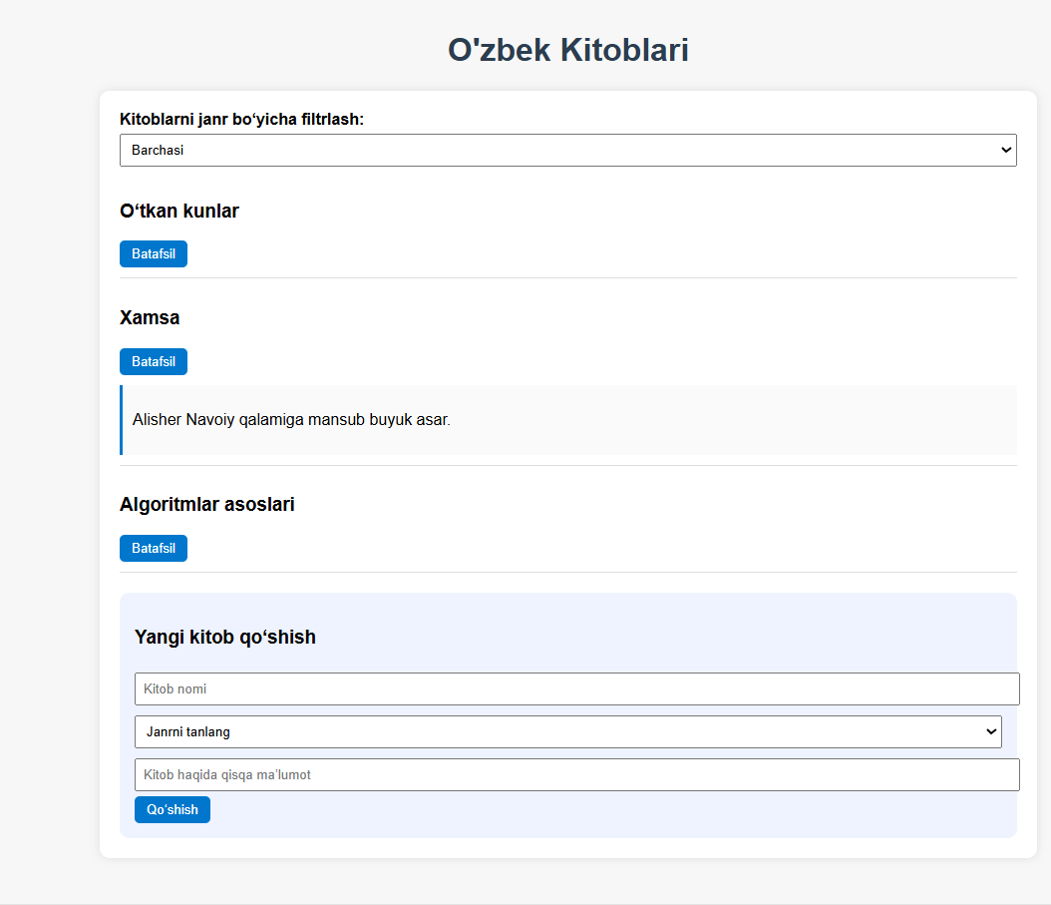
Xulosa
JavaScript eventlari veb-sahifalarni interaktiv holga keltiruvchi asosiy mexanizmdir. click, submit va change kabi hodisalar foydalanuvchi harakatlariga real vaqt rejimida javob berish imkonini yaratadi. Bu eventlar yordamida tugmalar, formalar va kiritilayotgan ma’lumotlarni boshqarish osonlashadi. Eventlarni to‘g‘ri qo‘llash esa veb-ilovalarning funksionalligini oshiradi va foydalanuvchi tajribasini sezilarli darajada yaxshilaydi

